**GenAI-PM Project Output Evidence Doc**

**Codespace GIT Env access:  
https://github.com/ajitsamalucsb/ucsb/tree/master**

1. Report the total number of tasks that are overdue:  
   Code reference(taskOverDueCount.py)

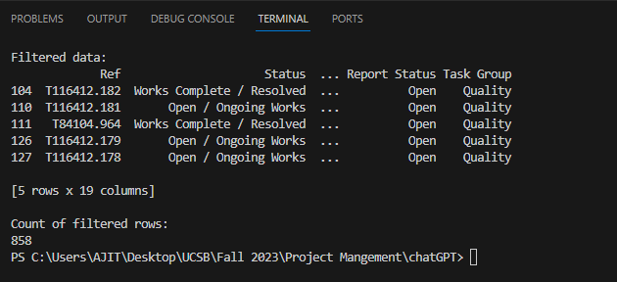

Also tried to generate the HTML output:  
Code reference(taskOverDueCountHTML.py)

<file:///C:/Users/AJIT/Desktop/UCSB/Fall%202023/Project%20Mangement/chatGPT/output.html>

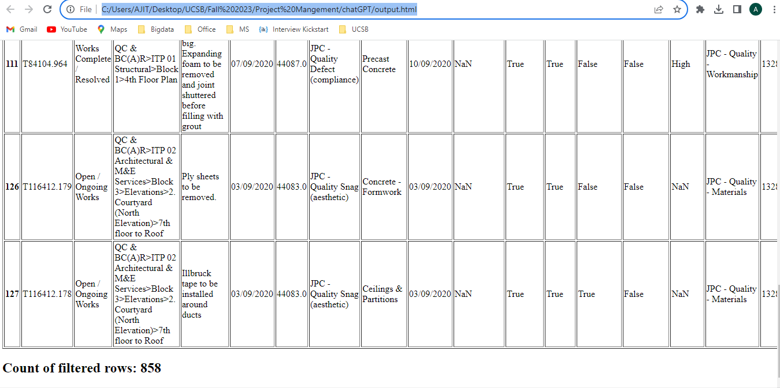

1. **Report the Total Number of Open and Closed Tasks by Each Task Group**Code reference(taskGroupByReportStatus.py)

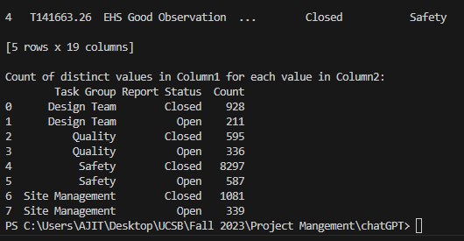

**Also refer the Status column to get the Task Group count**

Code reference(taskGroupByStatus.py)  
  
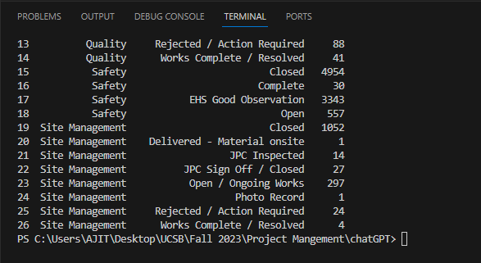

**3.Create a bar chart of the total number of open and closed tasks by each Task Group**Code reference(barChartByTaskGrpStatus.py)

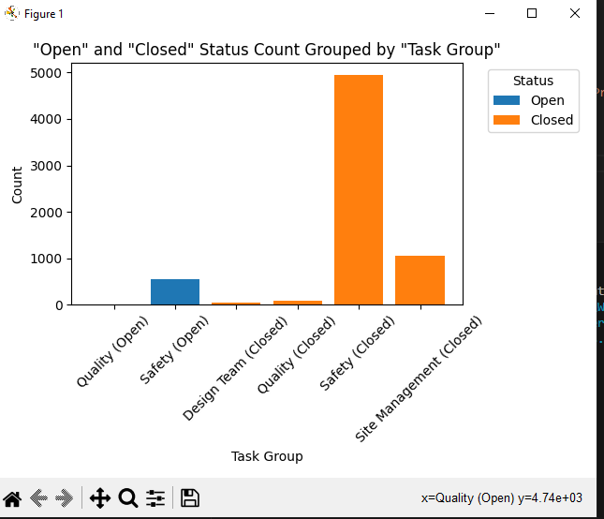

**4. Create a bar chart of the total number of overdue tasks by project**Code reference (barChartOverDueTaskGrpProject.py)  
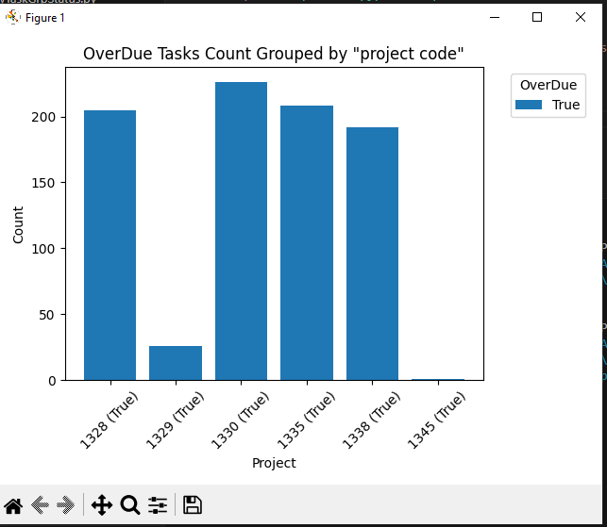

**5. Create a bar chart of the percentage of overdue tasks by project. *(Optional)***

Code reference (barChartOverDuePercentByProject.py)

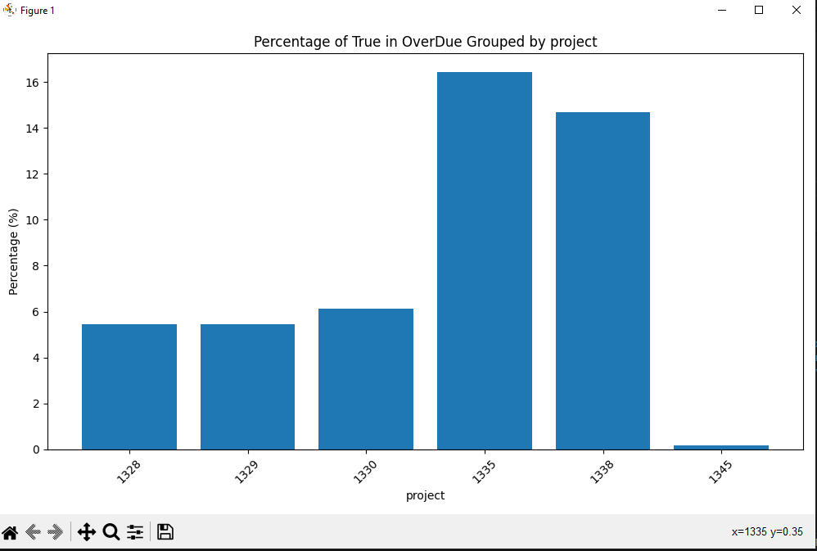

**6. Report the mean number of days elapsed since forms were opened by project.*(Optional)***

Code reference(meanElapseDaysByProject.py)

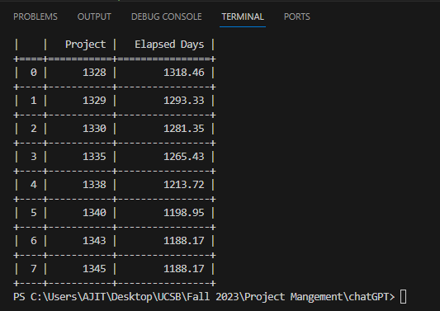

**Additional Try:  
1.Creating HTML Output**Code reference(meanElapseDaysByProjectHTML.py)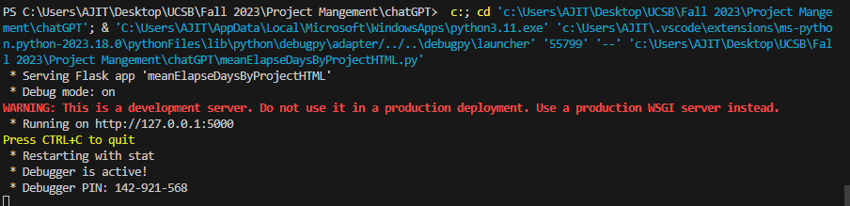

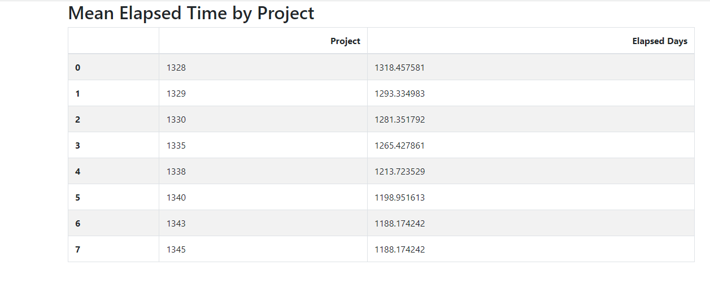

**2.Creating pdf output with chart**

**(**reference script: meanElapseDaysByProjectPDFOutputScript.py**)**

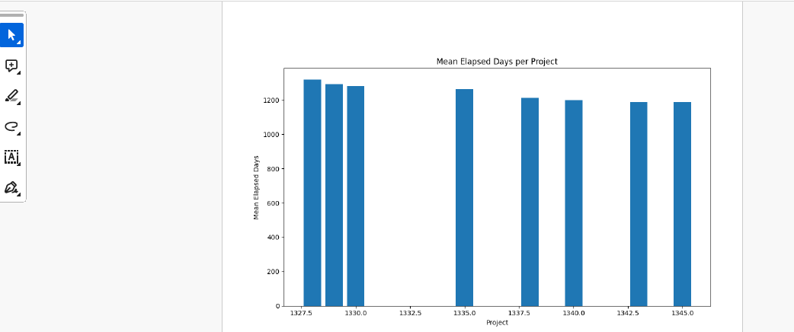

**3.Sending report output over email  
(**reference script: meanElapseDaysByProjectSendEmailScript.py**)**

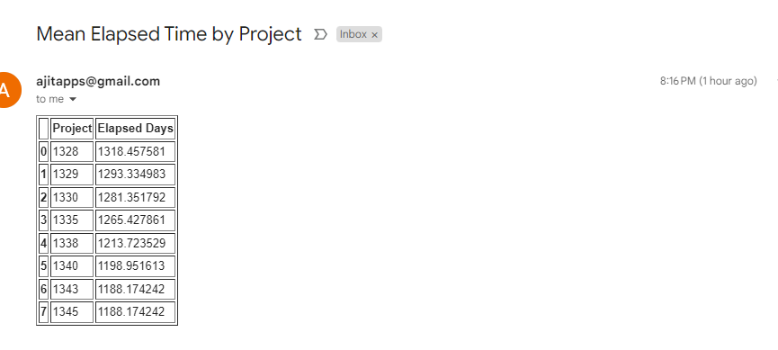

**7. Create a bar chart of the number of open forms by Type of form. (*Optional)***

**(**reference script: openFormByFormType.py**)**

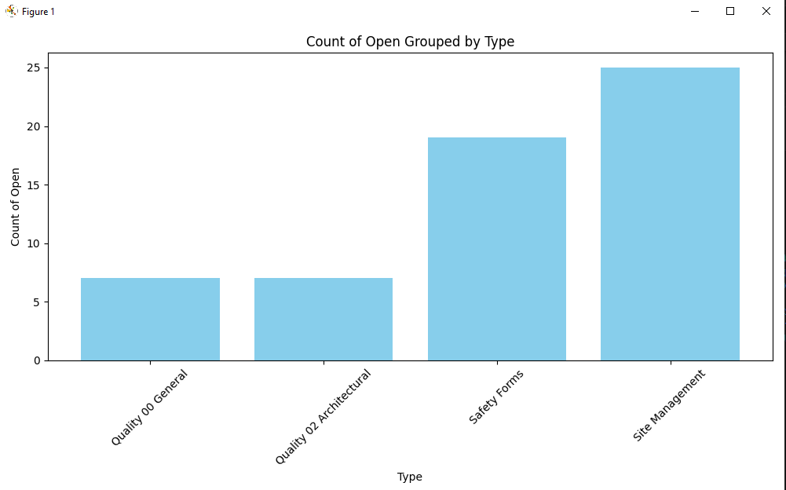

1. Create a time series plot of the number of forms opened (which are currently open) by Report Form Group. *(Optional)*

**(**reference script: openFormByFormType.py**)**

